- - Carga Datos Tabla Historial

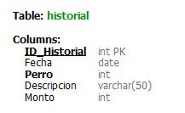 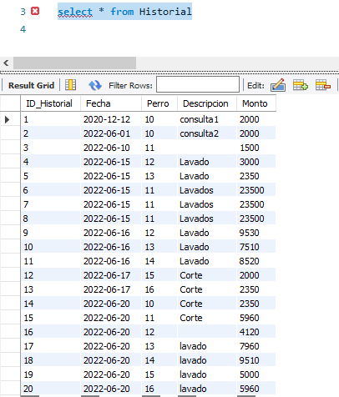

insert into Historial values(1,'2020-12-12',10,'consulta1',2000)

insert into Historial values(2,'2022-06-01',10,'consulta2',2000)

insert into Historial values(3,'2022-06-10',11,'',1500)

insert into Historial values(4,'2022-06-15',12,'Lavado',3000)

insert into Historial values(5,'2022-06-15',13,'Lavado',2350)

me falto copiar algunas inserciones

insert into Historial values(9,'2022-06-16',12,'Lavado',9530)

insert into Historial values(10,'2022-06-16',13,'Lavado',7510)

insert into Historial values(11,'2022-06-16',14,'Lavado',8520)

insert into Historial values(12,'2022-06-17',15,'Corte',2000)

insert into Historial values(13,'2022-06-17',16,'Corte',2350)

insert into Historial values(14,'2022-06-20',10,'Corte',2350)

in insert into Historial values(15,'2022-06-20',11,'Corte',5960)

insert into Historial values(16,'2022-06-20',12,'',4120)

insert into Historial values(17,'2022-06-20',13,'lavado',7960)

insert into Historial values(18,'2022-06-20',14,'lavado',9510)

insert into Historial values(19,'2022-06-20',15,'lavado',5000)

insert into Historial values(20,'2022-06-20',16,'lavado',5960)